|  |  |
| --- | --- |
| No. of Pages | **6** |
| No. of Questions | 7 |

**Department of Computer Science and Engineering**

**FINAL EXAMINATION SUMMER 2016**

**CSE421/EEE 465: Computer Networks**

**Total Marks: 100 Time Allowed: 2.5 Hours**

* Answer **Any** **Five (5)** questions out of **Seven (7)** questions.
* Figure in bracket [] next to each question indicates marks for that question.

###### Question No. 1

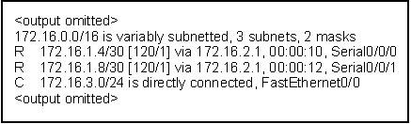

**Figure No. 1**

1. Based on the figure no. 3 shown above, which are Level 1 parent route and Level 2 Child route? What is the benefit of having Level 1 Parent route? [2+3 marks]
2. Refer to figure no. 1, what do the following values represent [2+2 marks]
   1. [120/1]
   2. 00:00:10
3. What is the purpose of the following two commands: [4 marks]
   1. default-information originate
   2. redistribute static

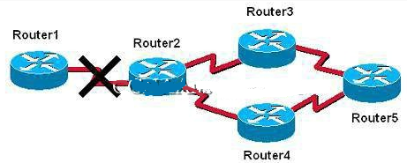

**Figure No. 2**

1. Refer to the above figure no. , Router3 after not receiving any update for 180 secs form Router2 considers that the link between Router2 and Router1 is down. And starts its timer of 180 secs. Then in few seconds it recives an update from Router5 that the link between Router1 and Router2 is 3 hops away.
   1. Will Router3 update the route for the link to up, why or why not?
   2. The two timer of 180 secs mentioned in the question above are same or different? Explain briefly your answer. [3+4 marks]

###### Question No. 2

1. You get a call from a network administrator who tells you that he typed the following into his router as shown in figure no. 5:

**Figure No. 5**

Router(config)#router ospf 1

Router(config-router)#network 10.0.0.0 255.0.0.0 area 0

He tells you he still can't see any routes in the routing table. What configuration error did the administrator make? And explain what the “1” represents written after “router ospf”. [4 marks]

1. There are three possible routes for a router to reach a destination network. The first route is from OSPF with a metric of 782. The second route is from RIPv2 with a metric of 4. The third is a static route configured by the administrator. Which route will be installed by the router in its routing table and why? [3 marks]

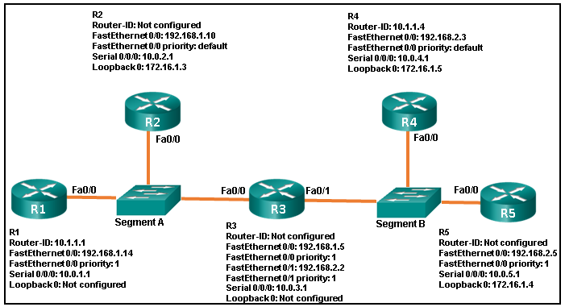

**Figure No. 6**

1. Refer to figure no. 6 above; identify all the router IDs and the DR and BDR. [Marks 5+1+1]
2. For two routers to become OSPF neighbors, what information needs to match? [3marks]

###### Question No. 3

1. Refer to the figure no. 7 below; Router R1 is configured as the DHCP server for the network 172.18.32.0/24 as shown. The users are faced with several problems.
   1. The users are not able to access the web server using [www.techno.com](http://www.techno.com) via their web browser, but they are able to ping the web server using 172.18.32.252. Find and solve the problem.
   2. The users are not able to access any sites over the Internet, find and solve the problem. [2.5+2.5 marks]

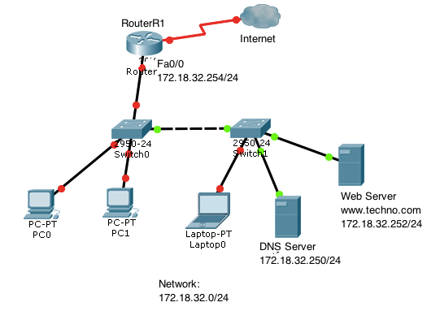

<output omitted>

ip dhcp-excluded address 172.18.32.249 172.18.32.253

ip dhcp pool techno

network 172.18.32.0 255.255.255.0

default-router 172.18.32.253

!

interface FastEthernet 0/0

ip address 172.18.32.254 255.255.255.0

duplex auto

speed auto

!

<output omitted>

**Figure No. 7**

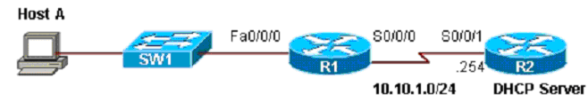

**Figure No. 8**

1. Host A is not able to receive any IP configuration from the DHCP server shown in figure no.8? What could be the reason/s? And how to solve the problem? [4 marks]
2. Differentiate between public and private IP addresses? [3 marks]
3. What commands are used to statically map the following private address 10.0.0.10 / 24 to the public address 141.63.7.20 / 28 using NAT? When do we need this kind of static mapping? [4 marks]
4. Refer to figure no. 9 below. What are the reasons that explain why none of the workstations are able to access the Internet? [4 marks]

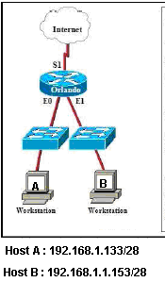

**Figure No. 9**

Orlando#show running-config

<-output omitted->

Hostname Orlando

!

interface Ethernet0

ip address 192.168.1.129 255.255.255.240

ip nat outside

!

interface Ethernet1

ip address 192.168.1.145 255.255.255.240

!

interface Serial1

ip address 201.201.201.1 255.255.255.0

ip nat inside

!

ip nat pool Sales 201.201.201.5 201.201.201.15 netmask 255.255.255.0

!

access-list 1 permit 192.168.1.0 0.0.0.255

<output omitted>

###### Question No. 4

1. Determine the compact IPv6 address of the following hosts : [2+2+1 marks]
   1. 203c: 0fdc:0000:0:0000:0: 201:1bc5
   2. 30f:0:0:0000:3034:0:0000:0
   3. 0:0000:0:0:0000:0000:0000:0001
2. What is the purpose of the ‘Next Header’ field in IPv6 packets? And how are they linked if multiple headers are present? [1+3 marks]
3. What will be the EUI-64 bit address for a device with MAC address 0021:2fb5:6e10. Don’t forget to invert the U/L bit. [3 marks]
4. How is anycast different from multicast? [2 marks]
5. Draw the process of stateless DHCPv6. [6 marks]

###### Question No. 5

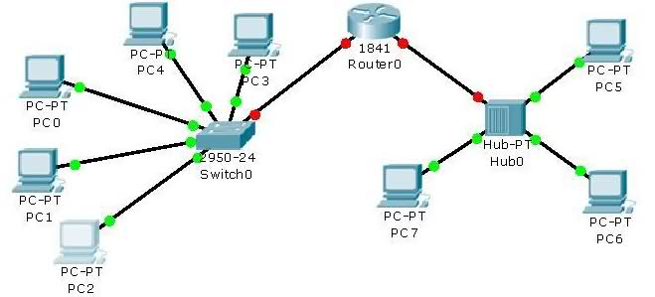

**Figure No. 10**

1. Refer to the above figure how many collision domains and broadcast domains are available? What if the hub is replaced by a switch, then will there be any change in the numbers? [3 marks]

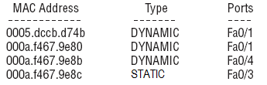

**Figure No. 10**

1. Which table consist of the above output, shown in figure no. 10? Why are there two MAC addresses associated with one port? And what does the type “STATIC” and “DYNAMIC” refer to? [5 marks]
2. In which scenarios will Asymmetric switching be preferable than Symmetric switching? [3 marks]
3. When will this command “ip default-gateway 172.16.1.254” be needed in a switch? [2 marks]

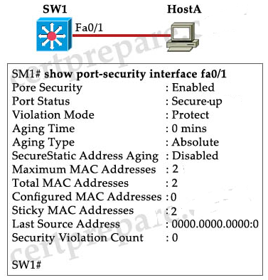

1. Refer to the output shown in figure no. , answer the following questions. [2+3+2 marks]
   1. An outsider plugs in fa0/1 and tries to send data, what will happen?
   2. The outsider turns the switch off and on again. Then he tries again to send data, will he be able to, explain?
   3. Will there be any difference if the violence mode was configured as “shutdown” instead of “protect”? If so what is the difference?

###### Question No. 6

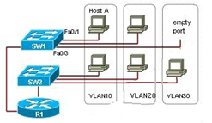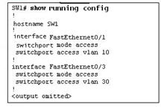

**Figure No. 10**

1. Refer to the figure no. 2 above. What would happen if the network administrator moved the network cable of Host A from interface Fa0/1 to Fa0/3 on switch SW1? [3 marks]
2. What is the purpose of Dynamic Trunking Protocol? Two switches are connected. If one of the end of the link is in dynamic desirable and the other is in dynamic auto, will the link be a trunk or not? [3 marks]

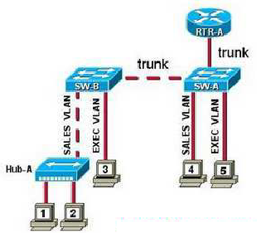

**Figure No. 10**

1. An ARP request it sent by computer 4 shown in figure no. 3. Which device or devices will receive this message, explain why? If the router RTR-A is removed, what impact will it create on the switched network, explain? [5 marks]
2. What measures are required to ensure that VLAN Double Tagging and VLAN Hopping attacks can be prevented? [4 marks]

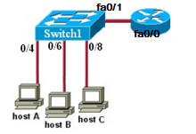

Router(config)#interface fastethernet 0/0.2

Router(config-subif)#ip address 192.168.1.1 255.255.255.240

Router(config)#interface fastethernet 0/0.3

Router(config-subif)#ip address 192.168.1.33 255.255.255.240

Router(config-subif)# interface fastethernet 0/0.4

Router(config-subif)#ip address 192.168.1.49 255.255.255.240

Switch 1# show interfaces trunk

Port Mode Encapsulation Status Native vlan

Fa0/0 desirable 802.1q trunking 1

Port Vlan allowed on trunk

Fa0/0 1,2,5

**Figure No. 10**

1. Refer to figure no. 3. Switchport 0/4 is on VLAN2, port 0/6 is on VLAN3, port 0/8 is on VLAN4. Part of the switch and router configuration is shown. None of the hosts are able to communicate with each other, find the problem and provide the solution. [5 marks]

**Figure No. 11**

###### Question No. 7

1. If there are no matches to the parameters define in an ACL, what happens? Why? [3 marks]
2. Using figure no. 11, create a Named Extended Access List to allow host 192.167.10.10 to telnet into the FTP server located at 210.93.105.50, but prevent any other hosts from 192.167.10.0/26 network to telnet into the FTP server. All other traffic is allowed. Do not forget to place the ACL. [7 marks]

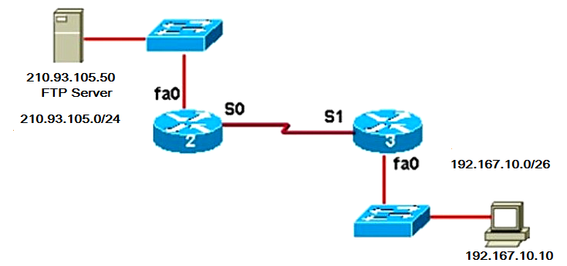

**Figure No. 11**

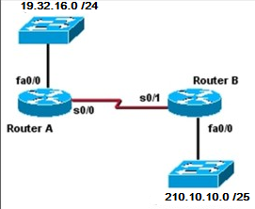

**Figure No. 12**

1. Refer to the figure no. 12, create a standard numbered ACL that will deny traffic from 210.10.10.0/25 network to the 19.32.16.0/24 network but will allow traffic from all other hosts. Where shall you place the ACL? [6 marks]
2. Write a named standard ACL that will only allow the host 19.32.16.10 to telnet into the Router A. Do not forget to place the ACLs appropriately. [4 marks]

##### THE END